

## Walchand College Of Engineering, Sangli.

#### (An Autonomous Institute)

**Department Of**

#### Computer Science and Engineering

TY CSE Mini Project-I

Report

On

**Fake review Detection using Machine Learning**

Submitted by

**Prachi Chobhare PRN:2019BTECS00022**

**Kshitija Jadhav PRN:2019BTECS00053**

**Anushka Thaware PRN:2019BTECS00106**

Under the Guidance of

**Prof.**

Computer Science & Engg. Dept,

WCE, Sangli.

##### 

##### 

**2021-2022**



Walchand College of Engineering, Sangli

(An Autonomous Institute)

**Department Of**

**Computer Science and Engineering**

### CERTIFICATE

This is to certify that the Project Report entitled,**”** **FLOWER DISEASES IDENTIFIER USING ARTIFICIAL NEURAL NETWORKS”** submitted by Ms. Prachi Chobhare, Ms. Kshitija Jadhav, Ms. Anushka Thaware to Walchand College of Engineering, Sangli, India, is a record of bonafide Project work of course  *”Min Project 2”* carried out by hers under my/our supervision and guidance and is worthy of consideration for the award of the degree of Bachelor of Technology in Computer Science & Engineering of the Institute.

|  |  |
| --- | --- |
| **Prof. Aprupa Pawar** | **Dr. M. A. Shah** |
| Guide | Head Of Department |
| Computer Sci. & Engg. Dept, | Computer Sci. & Engg.Dept, |
| WCE, Sangli. | WCE, Sangli |

# Acknowledgement

The acknowledgement page depicts the gratitude, respect and thankfulness of the student towards the people who helped them in pursuing the project successfully and ensured successful completion and implementation of the project. In this page, the author expresses his gratitude and concern by using praising and thanks giving words.

(Acknowledgement to Director, HOD, Project Coordinator, Guide: Institute as well as Industry n others)

# Declaration

I hereby declare that work presented in this project report titled **” FLOWER DISEASES IDENTIFIER USING ARTIFICIAL NEURAL NETWORKS ”** submitted by us in the partial fulfillment of the requirement of the award of the degree of **Bachelor of Technology (B.Tech)** Submitted in the **Department of Computer Science & Engineering, Walchand College of Engineering, Sangli**, is an au- thentic record of my project work carried out under the guidance of (Sonali Rokade mam and she helps us through out of our time).

Date:

26/11/21

Place: Sangli

(Signature)

(Name of the Students):

**Prachi Chobhare,**

**Kshitija Jadhav,**

**Anushka Thaware**

Roll No:

**2019BTECS00022**

**2019BTECS00053**

**2019BTECS00106**

## Table Of Contents

1. Project title 6
2. Abstract 7
3. Introduction and Related work 8
4. Problem statement 8
5. Objectives 9
6. Methodology 10
7. Project Diagrams (UML diagrams, Flow chart etc.) 11
8. Testing (Unit, System, Integration etc.) 13
9. Results and Conclusion 15
10. References 16

11 Annexure A 17

###### List Of Figures

* + figure 1 example: Flow chart of Fake review detection

###### Acronyms

* + AN Acro name example
  + AN1 Another name

#### Project title:

#### Flower Diseases Identifier Using Convolutional Neural Networks

#### Abstract

This presents an automatic identification of flower diseases based on image processing techniques. In view of this, normal and diseased flower images are acquired to create a knowledge base where images are pre-processed and segmented to identify the region of interest. Texture features of images are extracted using Gabor feature extraction, from which we computed seven different measures of dispersion and central tendency with the purpose of reducing the dimensionality of features. Then, an artificial neural network is trained with seven input features extracted from individual images and eight output nodes representing thirty eight classes of diseases considered in this work. Unkown samples of flower images are then tested based on the training model and we achieved an average accuracy of 83.3% in the identification of the flower diseases.

#### Introduction and Related work

Floriculture as an industry is reported to have begun in the late 19th century in the United Kingdom. Historically, the industry has been dominated by the developed world where major producers and consumers exist. Over the past few decades, however, a paradigm shift in the floral industry has been observed when flower growers moved to the developing countries of Africa, South America and Asia due to better climatic conditions and cheaper production costs . In general, the floral industry has achieved significant growth worldwide where it has increasingly become a major source of revenue for some countries around the world. The industry has grown from less than $3 billion in the 1950s to more than $100 billion in 2003 in global trade volume . Ethiopia and Kenya are the biggest exporters of flowers in Africa, accounting for substantial percentage of export earnings for both countries .

#### Related work

We have used here keras liabaray for preprocessing, segmentation and feature extraction.

We have transfered it into array using metrics. Then We have used that array for training our model. Here We have used vggg19 convolutional neural network model from keras for our 38 classes that is part of deep learninig. Then we have set our model checkpoints and early stopping. Then saving our best model using epochs. After that for gaining

Input as image from user we have used gradio model. One function predicting class of disease and other to get our other objectives .

#### Problem statement

A generic system that automatically identifies flower diseases using artificial neural networks providing a prediction mechanism for unknown samples of flowers as well.

#### Objectives

#### Identify the flower disease by simply scanning image of effected flower.

#### Explaining in detail about disease with similar images.

#### Describe type and cause of disease.

#### Describe way the disease are spread.

#### Describe way the disease are managed.

#### Methodology

1. Pre-processing techniques.
2. Segmentation
3. Feature Extraction.
4. Convolutional Neural Network.
5. Vgg19 Model
6. Gradio Ml.

#### Project diagrams

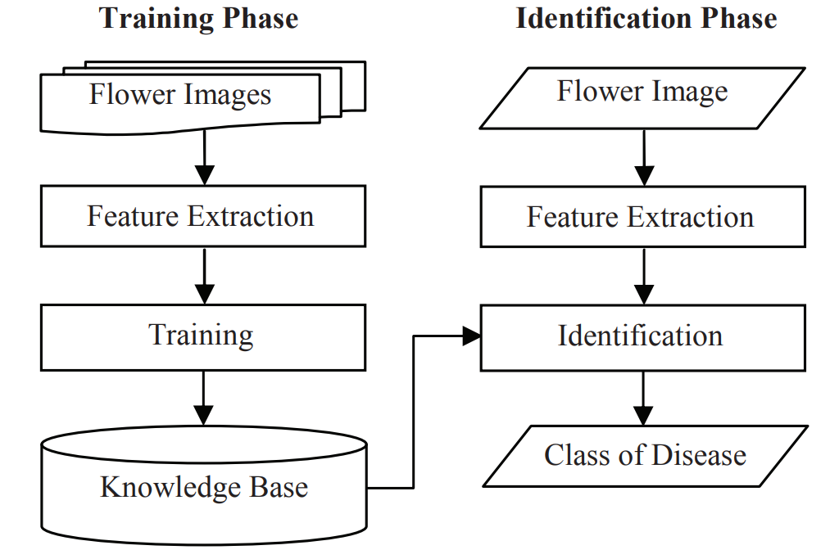

**Fig 1: Flow chart**

#### Testing (Unit, Integration and System)

........................

#### Results and Conclusion

........................ ........................

#### References

**References**

[1] R. Barbado, O. Araque, and C. A. Iglesias, “A framework for fake review detection in online consumer electronics retailers,” Information Processing & Management, vol. 56, no. 4, pp. 1234 – 1244, 2019.

[2] S. Tadelis, “The economics of reputation and feedback systems in ecommerce market places,” IEEE Internet Computing, vol. 20, no. 1, pp.12–19, 2016.

[3] M. J. H. Mughal, “Data mining: Web data mining techniques, tools and algorithms: An overview,” Information Retrieval, vol. 9, no. 6, 2018.

[4] C. C. Aggarwal, “Opinion mining and sentiment analysis,” in Machine Learning for Text. Springer, 2018, pp. 413–434.

[5] A. Mukherjee, V. Venkataraman, B. Liu, and N. Glance, “What yelp fake review filter might be doing?” in Seventh international AAAI conference on weblogs and social media, 2013.

**Annexure A**

1. **Final acceptance received from mentor on implemented product (Email screenshot)**